Angular Notes

-> install Angular Essentials extension, that is pack of more than 5 extensions that usefull for development in VS code.

-> TO run your Angular project hit npm start command

-> ACADEMIND_JETBRAINS is the code for free Jetbrains edditor for six months.

* Below are the Configuration files for TypeScript, generally no need to change. They are generally for the in built use to convert TypeScript code to JavaScript when software runs in browser.

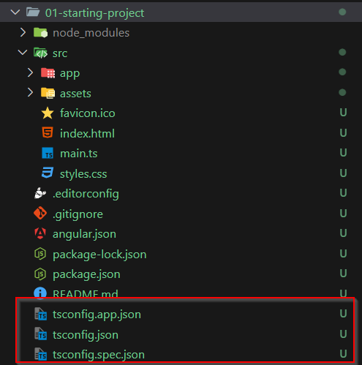

* Below files are main files about project introduction and for identify the project dependency for various npm pakages.

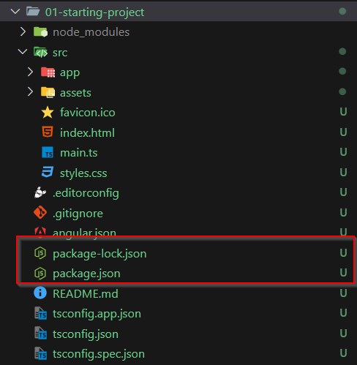

* Below file is generally use of the configuration of Angular and it’s various tools.

File name is angular.json.

* This src folder is main and important folder for your development code. Generally all files and folders comes under this folder.

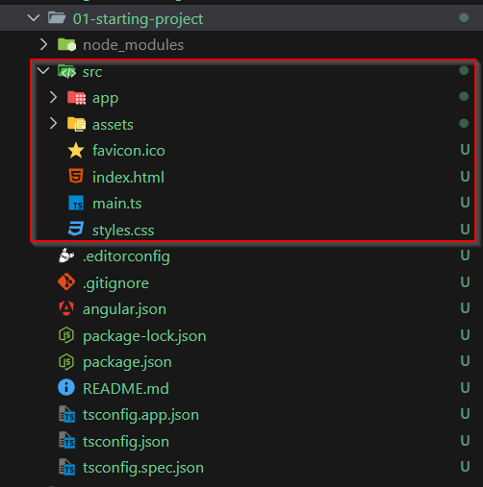

==== How Angular project runs.====

* First code file that execute after all configuration files is main.ts file.

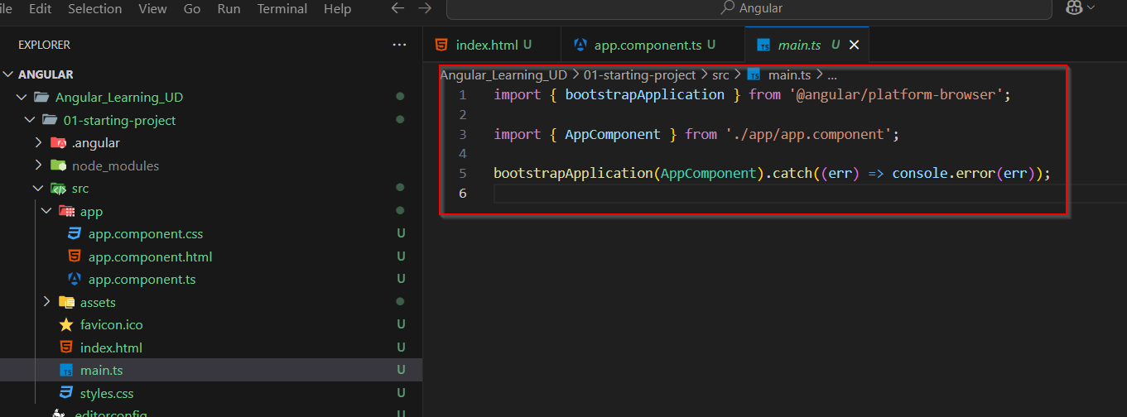

* Here we imported bootstrapApplication object from @angular/plarform-browser pakage.
* And another object imported is AppComponent that is from in built folder app/app.component.ts file.
* So When bootstrapApplication try to load AppComponent it will go to that app/app.component.ts file as per settings it loads it.

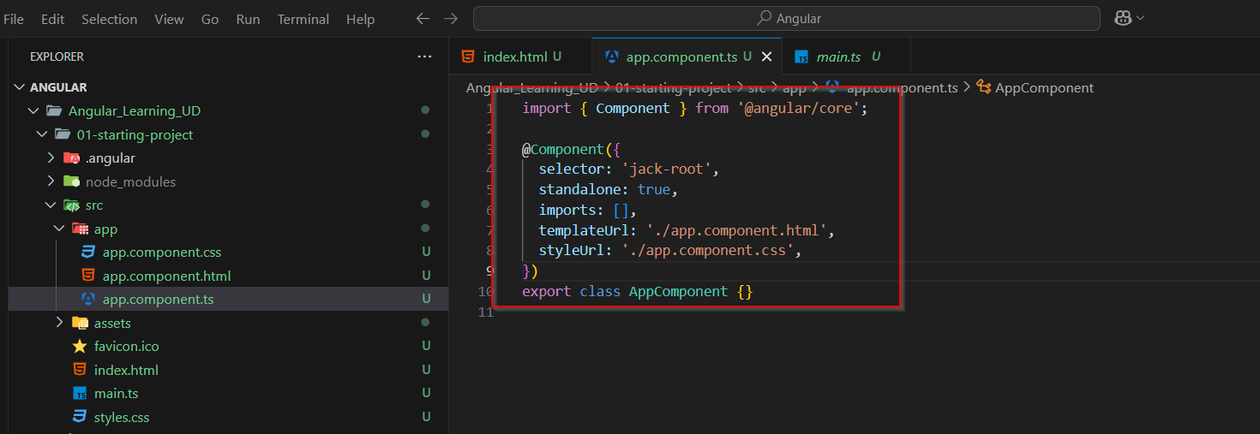

* Here Component object is imported from @angular/core pakage.
* @Component that is a decorative. This is TypeScript feature.
* Once this decorative is implemented with certain options, it will pass this all options or settings to below Javascript class that exported in same file AppComponent.
* Here one setting is “Selector” , it means browser will check for element in index.html file that is mentioned here in “selector” settings.
* And now in place of that element, for example here element is ‘jack-root’ , so browser finds the element ‘jack-root’ and replace it will what ever code return in file that is mentioned in “templateUrl” settings. Here in this case it is app.component.html.

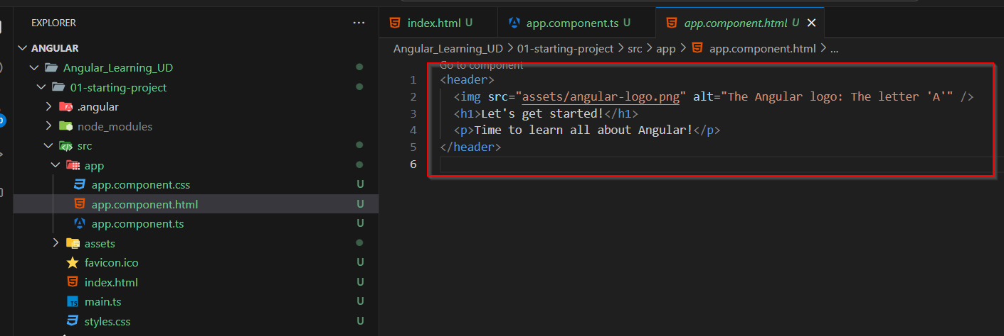

* While rendering this content it applies the style that is define in “styleUrl” settings file.
* In Angular it is recommended that App component should be the only root component and all other component should be render inside the root component.
* So for that we can register or we can say import other components in app component and then define it in “imports” array in @Compoent decorative as shown below in image.

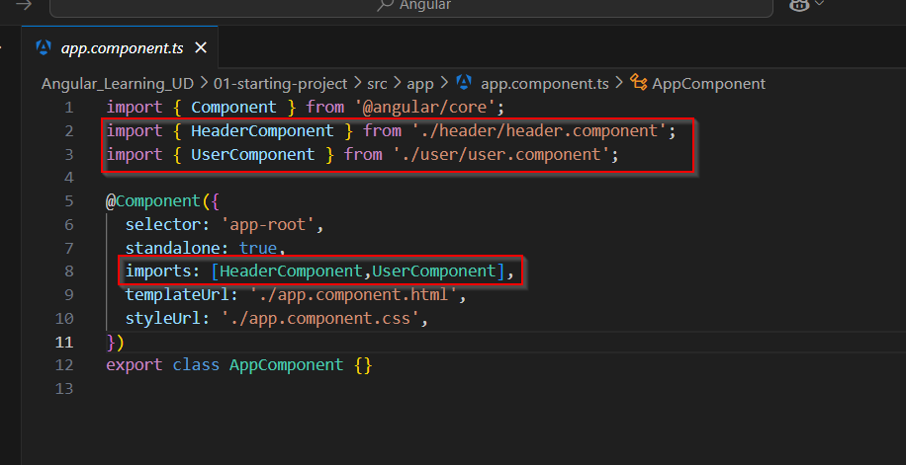

* Now to use those custom component modify app.component.html file accordingly.

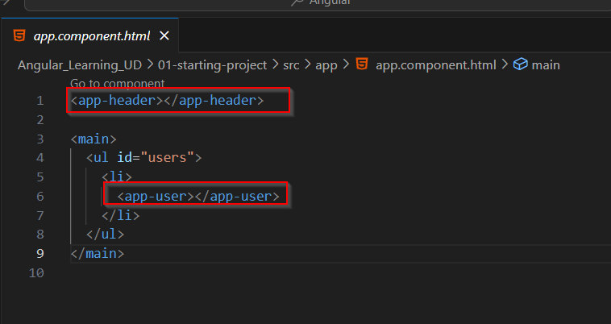

* Using ng g c command also components file can be generate. Seen as below in image.

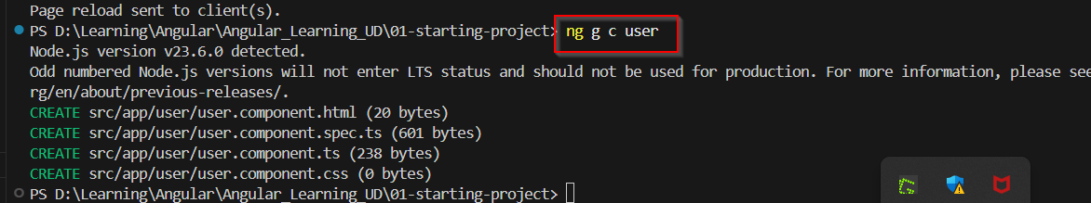

* Another important concept of Angular is we can define variable into the component class and that can be accessible in that component html file by default.
* Here selectedUser is available for user.component.html file.

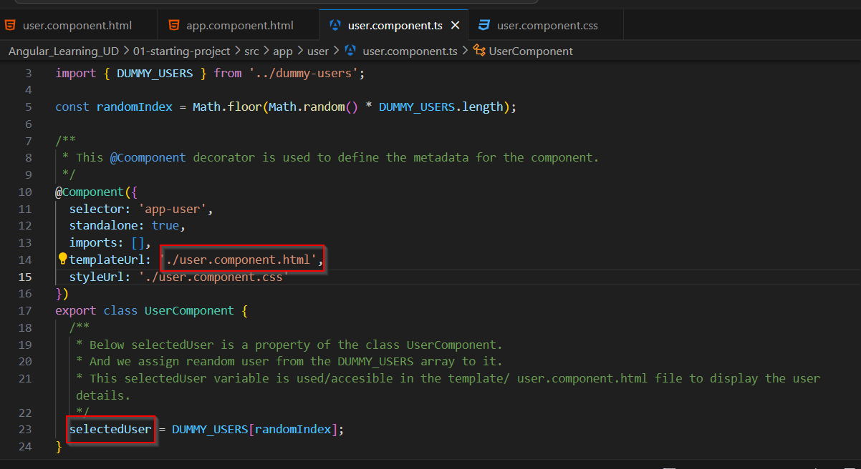

* We learn how we can use that class variable in html file
* As shown in below image we can use that variable via property binding or string interpolation.

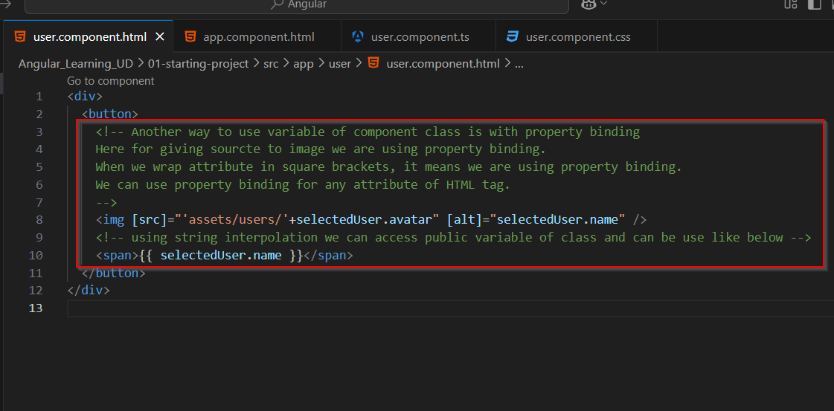

* Anther feature of TypeScript or JavaSCript we have inside class is getter or setter. We can simply use getter to get value of that property after assigned it. As shown in below image, now this “imagePath” variable is accessible in user.component.html file.

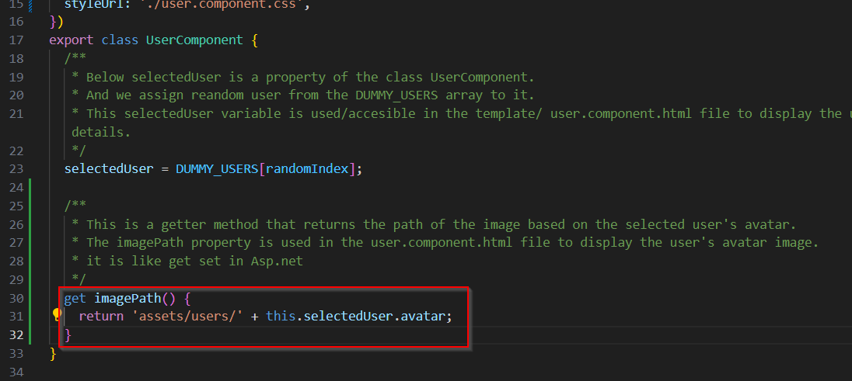

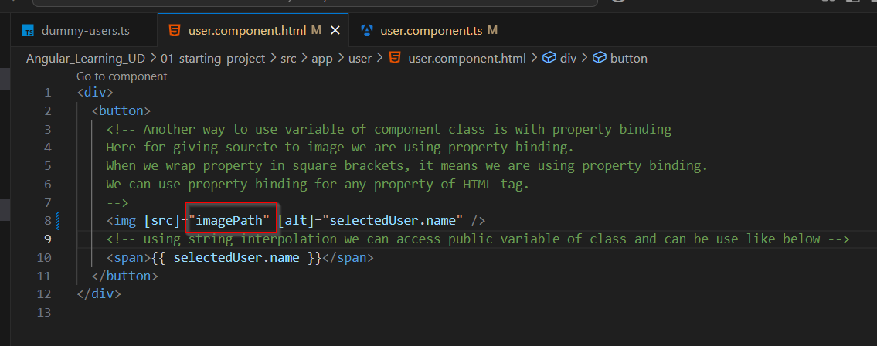

* We can define event listener in html element using round bracket, as shown in below image, Here we calling function that is written in component class file when user click on button and that’s why it is (click) event listener.

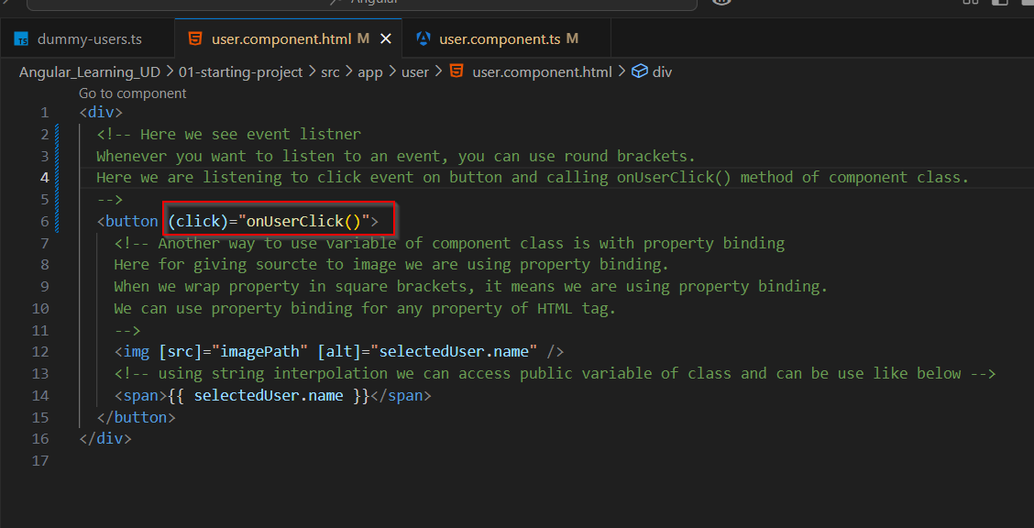

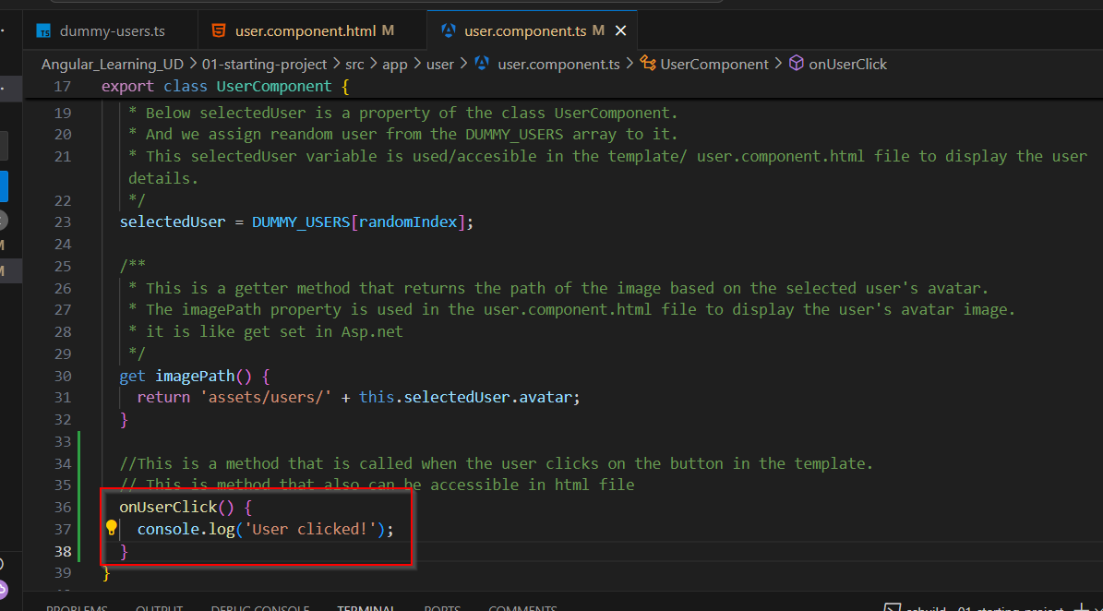

* Another concept in Angular is state management. As mentioned below in image.

